- Manpower Budgeting
- Headcount – separate the field for Additional Headcount Request. Make it total of all company, not per company. Therefore, Current Headcount + Additional Headcount = Total Headcount. Put also a separate field for additional headcount per company (OLC, OCC and OCLP).
- Move this section (highlighted in yellow) to the top. 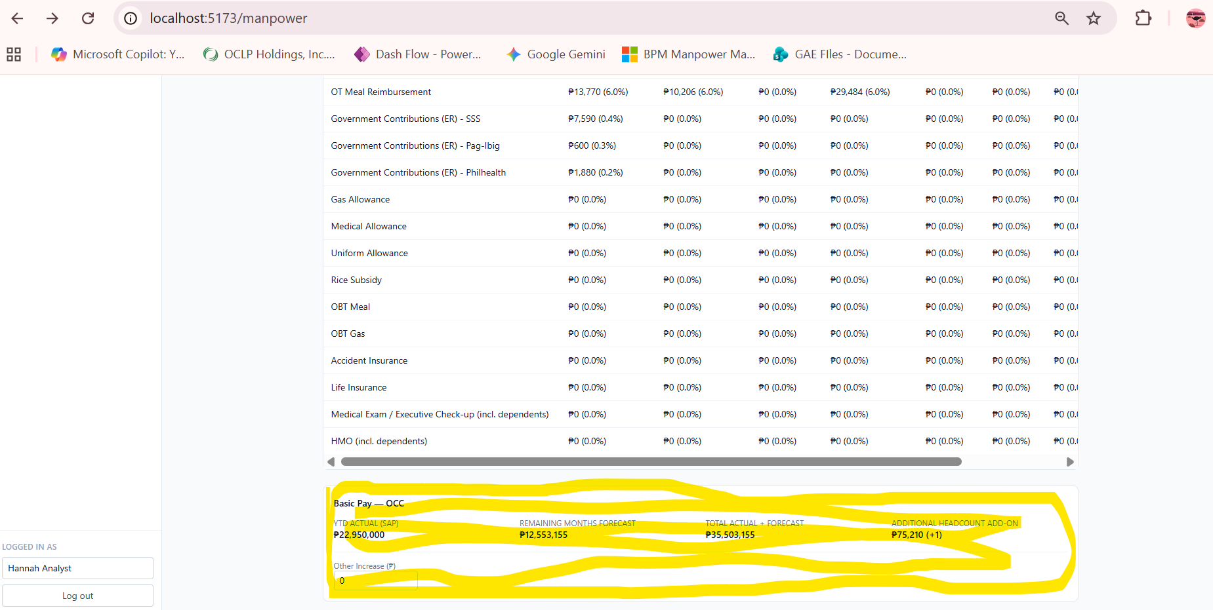
- Change the UI, it looks raw. You can change the font and add more color but maintain green theme.
- Put a click button to fill out the Average Salary and Government Contributions per employee rank. Employee rank is rank 1 to 12. Refer to file “Budgeting System_Manpower Template”, under “Average Salary” tabthe sample table to fill out.
- Put a click button to fill out the Headcount per employee rank per company. Refer to file “Budgeting System_Manpower Template”, under “Headcount per Company” tab for the sample table to fill out.
- Once the 2 tables above are completed, there will be a click button to run Manpower Budget report. Show only the summary total of Manpower Report shown in the excel file “Budgeting System_Manpower Report”, under tab “Dashboard Report”. Put a dropdown field to choose per company, then the Dashboard Report will update based on the chosen company. The sources of data per column for the Dashboard Report is indicated in the excel file, in row 2.
- Cancel Request button – make the font color red.
- Stage Due Dates – make the font color red if the day has already passed for that stage.

